**PROJECT PROPOSAL**

CSE5015 - Computing Project

***IoT based home power monitoring and controlling system***



**Higher Diploma in Network Technology and Cyber Security - CMU**

Faculty of Information Technology

International College of Business and Technology

Kandy

# Title Page

**IoT based home power monitoring and controlling system**

Group members

|  |  |  |
| --- | --- | --- |
| **KD/HDNET/CMU/01/11** | K.M.S.Dinuka Karunarathne |  |
| **KD/HDNET/CMU/01/16** | D.M.D.A. Dissanayaka |  |
| **KD/HDNET/CMU/01/07** | Chathura Jayasanka |  |
| **KD/HDNET/CMU/01/12** | W.M.K.G.Samarakoon |  |
| **KD/HDNET/CMU/01/02** | K.A.N. K.S. Kularathna |  |
| **KD/HDNET/CMU/01/09** | Isuri Tharushika |  |
| **KD/HDNET/CMU/01/10** | Sethmi Chethana Aththanayaka |  |
| **KD/HDNET/CMU/01/15** | W.M.N.Chameera Bandara Wijekoon |  |
| **KD/HDNET/CMU/01/08** | R.M. Thilini Ramanayake |  |

# Introduction

Energy consumption is a crucial aspect of modern living, and people are increasingly interested in monitoring and controlling their energy usage to reduce costs and promote sustainability. With the advent of the Internet of Things (IoT) technology, it is now possible to monitor and control energy usage in real-time. This project proposes the development of an IoT-based home current power monitoring and controlling system to provide users with an easy-to-use and efficient method of monitoring and controlling their home's power consumption. The proposed system aims to address the limitations of existing systems that are often expensive, complex, and difficult to install and use. By using sensors and microcontrollers to collect real-time data on energy usage, the system will provide users with valuable insights into their energy consumption patterns, helping them identify areas where they can reduce their energy usage and save money on their utility bills. Additionally, the system will enable users to control their energy usage remotely, either through a web-based interface or a mobile app, providing them with greater flexibility and convenience.

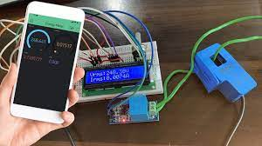

# Background study

Energy consumption is a major concern in modern society, with increasing energy costs and environmental awareness prompting many people to seek ways to monitor and control their energy usage. Traditional methods of energy monitoring and control have been limited by their high cost, complexity, and lack of real-time monitoring capabilities. However, the advent of the Internet of Things (IoT) technology has enabled the development of low-cost, real-time home current power monitoring and controlling systems that can provide users with valuable insights into their energy consumption patterns and enable them to optimize their energy usage. The proposed system will use relay modules to control home appliances and voltage and current sensors to collect real-time data on energy consumption. The data will be processed by a Node MCU ESP 32 module, which will communicate with a cloud-based server for data storage and analysis. The system will be capable of monitoring energy consumption in real-time and providing users with data analytics and decision-making tools to optimize energy usage. The advantages of the proposed system are numerous. First, it will be low-cost, making it accessible to a wide range of users. Second, it will be easy to install and use, with a simple user interface that can be accessed via a mobile app or web-based interface. Third, it will enable real-time monitoring and control of home appliances, giving users the ability to make immediate changes to their energy consumption patterns. Finally, it will provide users with valuable insights into their energy consumption patterns, enabling them to identify areas where they can reduce energy usage and save money on their utility bills. The proposed system will be particularly useful for households seeking to reduce their energy costs and promote sustainable living. By providing users with real-time data on energy consumption and the tools to optimize energy usage, the system can help users reduce their energy consumption, lower their utility bills, and reduce their carbon footprint. In summary, the proposed IoT-based home current power monitoring and controlling system represents a significant advancement in the field of energy monitoring and control, providing users with a low-cost, easy-to-use, and real-time system for optimizing energy usage and promoting sustainable living.

VOLTAGE MEASUREMENT

The voltage sensor used in our work is single phase AC voltage sensor is made of ZMPT101B voltage transformer. Figure 1 shows a chip image of ZMPT101B. It is high precision, good consistency for measuring voltage and power and can reach 250V AC. As well as low price, small size, and easy printed circuit board (PCB) mounting. The output signal from it, fed into the analog input channel of the microcontroller.

Imagine a scenario where you are living in a large house with multiple appliances and devices that consume significant amounts of power. You often struggle with high electricity bills, and you're curious about finding ways to reduce your energy usage and costs.

To tackle this issue, you decide to develop an IoT-based home power monitoring and controlling system. The system aims to provide real-time monitoring of the electricity consumption of individual appliances and devices throughout the house. It also allows you to remotely control the power supply of these appliances and devices.

The system consists of a central control unit that is connected to various smart power sockets and appliances throughout the house. The central unit monitors the power usage of each device and sends the data to a cloud server for storage and analysis. You can access the system's data via a web or mobile app that displays a dashboard of your power usage in real-time. The dashboard also highlights the most power-hungry devices, allowing you to identify areas where you can reduce consumption.

The system also enables you to set energy-saving rules and alerts that automatically turn off devices or reduce their power consumption during specific hours of the day or when you're away from home. You can customize these rules and alerts to suit your individual preferences and lifestyle.

In summary, this IoT-based home power monitoring and controlling system provides an intelligent and easy-to-use solution for reducing energy consumption and lowering electricity bills. With real-time monitoring and automatic control, you can optimize your energy usage and contribute to a greener and more sustainable future.

# Problem Statement / Description to the problem

At present, electrical capacity measuring devices are not used in homes in Sri Lanka. For example, there is no device to see how much electrical capacity is consumed by a kettle. Even if there are methods to bring from other countries, people do not use those methods because they are expensive. But having this device can reduce our electricity consumption. Due to the increase in electricity bills, these devices are very important for Sri Lanka.

# Literature review

A brief overview of the related techniques and literature on the study’s scope is discussed in this section. Four components are discussed, such as a monitoring system, a control system, IoT implementation, and other related techniques.

Nowadays, people’s dependency on electricity is extreme, as power consumption has increased for the past few years. It is imperative to consider monitoring and measuring the electric system or appliances that operate every day for residential and commercial buildings. As the focus of this article, the residential sectors are made up of small energy consumers and users, such as houses and apartments. The research suggested that the residential energy consumers waste 41% of the power supplied to their homes. Various research and trials have been shown that on average, savings of 7.8% to 16.7% home energy can be achieved by using a home energy monitoring system. Several case studies have been shown that energy consumption can be reduced by modifying the lifestyle with proper habits/behaviors.

A node microcontroller unit (NodeMCU) with a Wi-Fi-based gateway has been used to connect different sensors and update their data to the Adafruit IO cloud server. A power monitoring system can help users or consumers monitor their usage of electricity efficiently. Improvement of electricity efficiency usage can be made by reduction due to changing habits. In this modern era, monitoring systems must sort the data, record data in the system, exploit them to get the intrinsic information shown in legit and innovative ways, and access the Internet to efficiently visualize it. A power monitoring system can be considered a user-friendly and unified solution for reliable electricity management. This system can help users to change their use by providing real-time feedback.

The control system is a system that can control other things depending on what needs to be controlled. Local and remote control are included in the control application. Local control is an action that the control unit will take on its own, and remote control is a mechanism that remotely controls the IoT-based system. Electrical equipment operational status monitoring will reduce the cost of building power consumption and increase buildings’ electrical energy to a reasonable and efficient ratio. As all can be managed, control systems can help consumers handle their energy more effectively and efficiently. The control system controls the current in this study, which will be cut off if an overcurrent is found. This control system can raise awareness of the consumption of household appliances among users.

Technology is one of the main reasons for a country to become a well-developed country. Innovations and technology can likely change people’s lives and make the world more sustainable and inclusive. Internet of Things, known as IoT, is a new and ever-growing network that is becoming a hot topic in people’s conversations in the era of modern technology. IoT is a wide-open and complete network of smart and intelligent objects that has the full capability and capacity to auto organize; share information, data, and resources; and act and react to any circumstances or atmosphere of the changing environment. IoT is growing and needs to be sustained so that it will be the expanded, innovative concept in the IT world. IoT advancement controls the real Thing that will transform the Internet into a fully integrated Future Internet. Future information communication technology is to be used with embedded sensors. The target applications are smart metering, Internet-connected sensor devices for household appliances, emphasizing the benefits of remote real-time monitoring for household energy consumption appliances. The IoT applications have already brought attention to and shown the performance of monitoring modern household appliances’ energy usage toward a sustainable and improved quality of urban lifestyle. IoT is beneficial and recommended in smart home applications. It has improvised our quality of life and also can reduce the unnecessary costs of daily life. This wellness system has been implemented for many great things and monitoring and controlling the electricity at home. The information is uploaded to the website by a server using the cloud server’s local home gateway. However, security and privacy challenges have been raised due to the reliability and dependability issues of the Internet. This is because of some connections between the cyber environment and physical environment to fulfill the consumers’ demands. It is presumed that these problems will indeed be solved in the future, as shown in Figure 1.

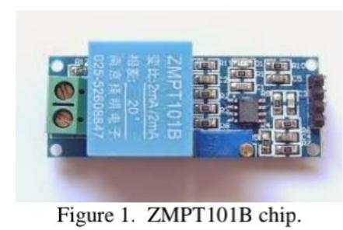

# Proposed Solution

Proposed a power management and control system based on wireless sensor networks. Where, wireless sensors were used to continually sense and updates electricity data and transmit it via ZigBee module, in order to provide real-time electricity consumption information to users and remote monitoring and control of home appliances were provided to users through web service. explored the concept of Smart Home through integrating IoT with Web services and Cloud computing. Their approach consisted of embedding intelligence into sensors and actuators using Arduino platform, networking smart things using Zigbee technology and facilitating interactions with smart things using Cloud services for easy access in different locations. The approach was successfully used for demonstrating services for measuring home conditions, monitoring home appliances, and controlling home access. The infrastructure can be adopted for or adapted to other applications. proposed the pattern of a smart monitoring and controlling system for household electrical appliances in real time. This system monitors electrical parameters of household appliances were done by interfacing with fabricated sensing modules for transmitting wirelessly by Zigbee protocol to central controller. In order to calculate the power consumed. this system implemented the controlling mechanism of appliances in different ways. the system was used for remote monitoring and control of appliances effectively through a website. Local and remote user interfaces were easy to handle by a consumer and are efficient in handling the operations. They designed the system to implement smart power monitoring and control through IoT using cloud data storage. Power consumed by various appliances is monitored through an ARM based controller interfaced to Hall Effect current sensors and stored in a cloud data base. Power control of home appliances is achieved through actuators such as relays which can be controlled by client with the help of a web server by establishing Remote Procedure Calls between client and server. The designed system was enabled client to monitor and control the appliances at home from anywhere availing the IoT features thereby reducing the wastage of energy. created a smart power monitoring and control system toward the usage of an intelligent building. This framework adequately screens and controls the electrical machine utilizations at an elderly home. The electrical parameters of home machines were International Journal of Embedded Systems and Applications monitored by interfacing with sensor modules and the yield signals from it were incorporated and associated with ZigBee module for transmitting electrical parameters data wirelessly to the host PC which was stored the information into a database. The- system intended to decide the zones of day-by-day peak hours of power use levels and accompany an answer by which the system can bring down the utilization and improve better use of effectively restricted assets during peak hours. reported an effective implementation for Internet of Things used for monitoring home appliances, presented wireless sensor networks based real time power management system to control and monitor the power consumption of electrical appliances in a home. For calculating the power consumption of electrical appliances was used current and voltage sensors. these measured data was transmitted wirelessly using Zigbee protocol to the Ethernet shield for monitoring and controlling remotely through a secured internet web connection. Thus, this system can reduce electricity cost of the consumers.

**Block Diagram**[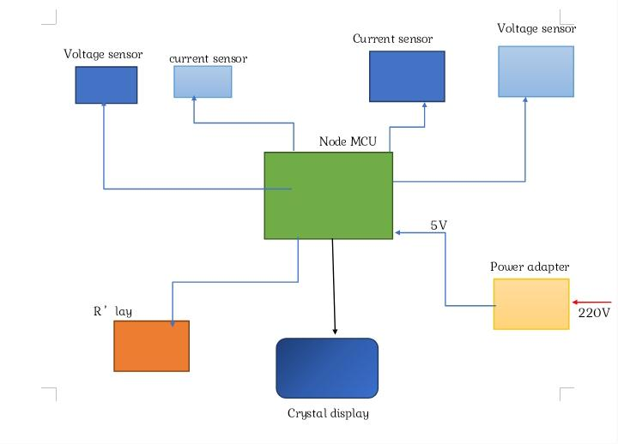](blob:https://web.whatsapp.com/d3ab00b6-ab5c-4aff-afe6-e4392270766f)

**Wiring Diagram**

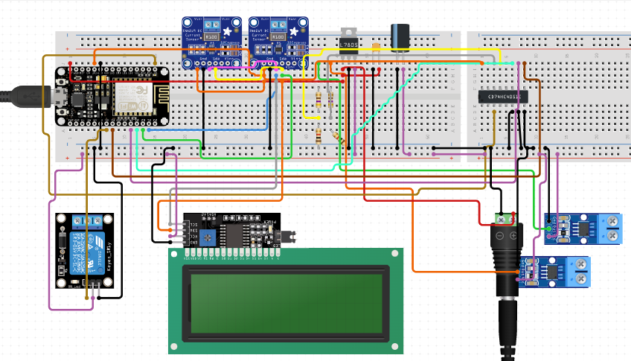

*Voltage Measurement*

The voltage sensor used in our work is single phase AC voltage sensor is made of ZMPT101B voltage transformer. Figure 1 shows a chip image of ZMPT101B. It is high precision, good consistency for measuring voltage and power and can reach 250V AC. As well as low price, small size, and easy printed circuit board (PCB) mounting. The output signal from it, fed into the analog input channel microcontroller.



*Current Measurement*

For sensing current, we used ACS712 current sensor. Figure 2 shows the ACS712 chip. The main features of this sensor used to measure AC/DC current up to 20A. Its operating voltage is 5V. The output signal is fed to analog input channel of microcontroller. This sensor works on the basis of the hall effect principle, when a current pass through a conductor that is positioned at a magnetic field, a voltage is produced across its edges orthogonal to current and magnetic field directions.

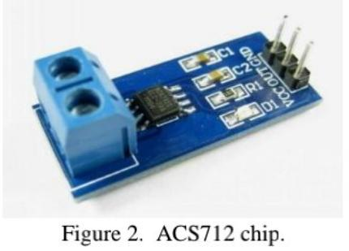

*System Overview*

The proposed system is consisted of three parts: smartphone application, base station, and sensing node. Starting from the bottom, the sensing node uses a hall-effect based AC Current sensor and a transformer-based AC voltage sensor with Arduino Uno microcontroller to calculate the real-time power consuming of connected electrical appliances.

*Power Measurement*

For calculating power of a single-phase AC circuit, the output of volts and amperes must be multiplied by the power factor. Power Factor is the cosine of the phase angle of voltage and current waveforms as shown in the Figure 3. It is one, if voltage and current are in same phase. The current sensor output signal depends entirely on the nature of the connected appliance, whether the connected load is pure resistive, capacitive or is inductive

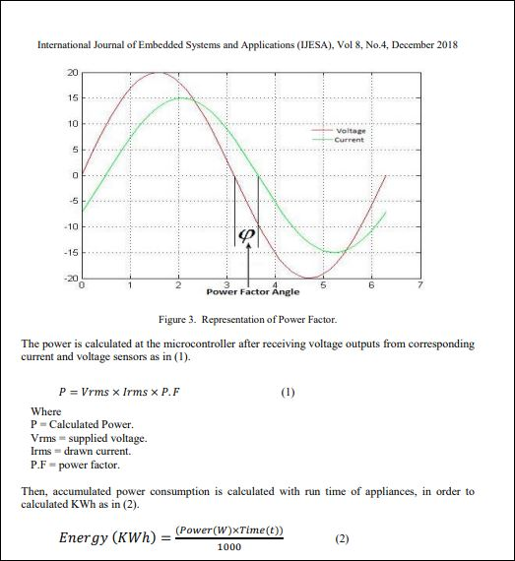

After completing the calculation, the measured readings will display using the liquid crystal display (LCD). In addition, relay is added to allow control of appliances either according to consumer requirements by sending commands wirelessly from a base station to a microcontroller or when exceeding permitted consumption limits, it will automatically turn off the power. ZigBee module will be responsible for sending wirelessly all the measured readings in this part to the base station. The base station is designed to receive all transmitted measured readings from sensing node to continue monitoring in real-time through GUI available at computer system and the mobile app window. Power monitoring feature allows the user to reduce the power consumption thus save cost. these measured readings are stored in database for further analysis. Then, these measured readings will be sent via internet to the upper most application layer which has different applications on different level for different purposes. For information accumulation and information preparing at base station it utilized microcontroller – NodeMCU is Wi-Fi ensured single chip microcontroller unit (MCU) shown [Figure 4 (a)]. known as a Wi-Fi Module, it has ability to perform Wi-Fi related activities like IoT applications and home automation. It is used as an alternative to Arduino Wi-Fi shield in order to connect to a Wi-Fi network, because it is considered an inexpensive alternative, International Journal of Embedded Systems and Applications (IJESA) with default firmware and it has the same functions as Wi-Fi Shield. It is also immediately breadboard friendly. It incorporates inserted TCP/IP stack and numerous Internet conventions for simple web get to.

There are three major parts to a smartphone application. They are the device, cloud server and the mobile app. all of these features and techniques utilized in this project are outlined below. Blynk is a smartphone application that allows the developers to create a custom app for their projects’ according to the application shown Figure 4 (b). It leverages the resources of a smartphone such as the touch screen to provide a set of widgets that assists to create a custom user interface to control the device remotely. It consists of two main elements, an application running on Android and iOS and a library compatible with the Wiring framework with our project board. Blynk app that is shown in Figure 4 (c) handles the data translation between the device and the smartphone app.

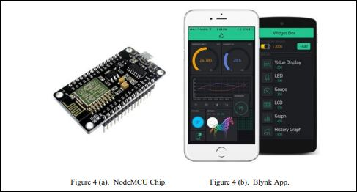

When the project application is registered; the server issues authentication token which must be included in the main project code. It also enables the device to communicate between each other and also between other web applications over internet. Before associating the gadget to a get to access point, it needs to join the system safely. Wi-Fi provisioning is the process of connecting a new Wi-Fi device (station) to a Wi-Fi network. The provisioning process involves loading the station with the network name referred as SSID and its security credentials. The user needs to send the predefined password. User can download the android mobile app from Google Play or iOS mobile app from App Store. Figure 5(a) and Figure 5(b) illustrate wiring diagram of base station and sensing node, Figure 6 depicts the fabricated system with the integrated sensing circuit and ZigBee module.

# Justification to the solution

*Problem Statement 1: "Inefficient Energy Usage in Residential Buildings"*

One of the major problems faced by households is the inefficient use of energy, which leads to high electricity bills and wastage of resources. The traditional methods of monitoring power consumption and controlling appliances are often cumbersome and ineffective, which results in excessive energy consumption. There is a need for an IoT-based home power monitoring and controlling system that can help households reduce their energy usage and save money.

The proposed solution would involve the installation of sensors and smart meters in the household, which would monitor the power consumption of various appliances and devices in real-time. The data collected by these sensors would be transmitted to a central system, which would analyze it and provide insights into the energy usage patterns of the household. Based on these insights, the system would be able to suggest ways in which energy usage can be reduced, such as turning off appliances when they are not in use, optimizing the use of heating and cooling systems, and using energy-efficient appliances.

*Problem Statement 2: "Difficulty in Managing Power Supply during Peak Hours"*

Another major problem faced by households is the difficulty in managing power supply during peak hours. During peak hours, the demand for electricity is high, and the supply often falls short. This can lead to power outages, which can be disruptive and inconvenient for households. There is a need for an IoT-based home power monitoring and controlling system that can help households manage their power supply during peak hours.

The proposed solution would involve the installation of smart meters and sensors in the household, which would monitor the power consumption of various appliances and devices in real-time. The data collected by these sensors would be transmitted to a central system, which would analyze it and provide insights into the energy usage patterns of the household. Based on these insights, the system would be able to suggest ways in which energy usage can be reduced during peak hours, such as turning off non-essential appliances and devices, optimizing the use of heating and cooling systems, and using energy-efficient appliances.

*Problem Statement 3: "Safety and Security of Home Electrical Systems"*

The safety and security of home electrical systems are critical concerns for households. Faulty wiring, overloaded circuits, and other electrical issues can lead to fires, electrocution, and other hazards. There is a need for an IoT-based home power monitoring and controlling system that can help households ensure the safety and security of their electrical systems.

The proposed solution would involve the installation of sensors and smart meters in the household, which would monitor the power consumption of various appliances and devices in real-time. The data collected by these sensors would be transmitted to a central system, which would analyze it and provide insights into the electrical systems' safety and security. The system would be able to detect potential hazards, such as overloaded circuits and faulty wiring, and alert the homeowners to take appropriate action. The system could also include features such as automatic circuit breakers and surge protectors to prevent electrical hazards from occurring.

# Scope of the System

*Scope of the System 1: "Integration with Smart Home Systems"*

The IoT-based home power monitoring and controlling system would offer integration with smart home systems. The system would be able to work seamlessly with other smart home devices, such as smart thermostats, lighting systems, and security systems, to provide homeowners with a fully automated and connected home.

The system would be able to communicate with these devices and make adjustments based on the energy usage patterns of the household. For example, the system could turn off the heating or cooling system in a room that is not in use or adjust the lighting in a room based on the time of day. The system could also work with smart locks and security systems to provide an added layer of security to the household.

*Scope of the System 2: "Data Analysis and Reporting"*

The IoT-based home power monitoring and controlling system would offer data analysis and reporting capabilities. The system would collect data on the energy usage patterns of the household and provide insights into how energy is being used. The system would be able to generate reports that show energy usage trends, identify areas where energy could be saved, and suggest ways in which energy usage can be reduced.

The system would also be able to provide real-time feedback to homeowners on their energy usage and provide alerts when energy usage exceeds certain thresholds. The system could also provide feedback on how much money the homeowner is saving on their electricity bills by using the system.

*Scope of the System 3: "Expandable and Scalable"*

The IoT-based home power monitoring and controlling system would be expandable and scalable, allowing homeowners to add new devices and sensors as needed. The system would be designed to work with a wide range of appliances and devices, and homeowners could add new sensors and devices as they purchase them.

The system would also be scalable, allowing homeowners to expand the system as their needs grow. For example, a homeowner could start with a basic system that monitors energy usage and controls a few appliances and then gradually add more devices and sensors as needed.

The system would be designed to be modular, with different components that can be easily added or removed as needed. The system would also be flexible, allowing homeowners to customize the system to suit their needs and preferences.

# Methodology & Technology

*Methodology and Technology 1: "Sensor Networks and Data Collection"*

The IoT-based home power monitoring and controlling system would use sensor networks and data collection to monitor energy usage in the household. The system would use a variety of sensors, including smart meters, current sensors, and voltage sensors, to collect data on the energy usage of different appliances and devices.

The data collected by these sensors would be transmitted to a central system, where it would be analyzed and processed. The system would use machine learning algorithms to identify patterns in the energy usage data and make recommendations on how to optimize energy usage.

*Methodology and Technology 2: "Internet of Things (IoT) Architecture"*

The IoT-based home power monitoring and controlling system would use an IoT architecture to connect different devices and sensors. The system would consist of a central hub that would connect to various sensors and smart devices throughout the household. The central hub would use Wi-Fi or Bluetooth technology to communicate with the sensors and devices.

The IoT architecture would allow the system to be scalable and expandable, with the ability to add new devices and sensors as needed. The system would also be able to work with other IoT devices and services, such as smart home assistants and cloud-based analytics services.

*Methodology and Technology 3: "Cloud-Based Analytics and Machine Learning"*

The IoT-based home power monitoring and controlling system would use cloud-based analytics and machine learning to process and analyze the data collected by the sensors. The system would use advanced machine learning algorithms to identify patterns in the energy usage data and provide recommendations on how to optimize energy usage.

The system would also use cloud-based analytics to provide real-time feedback to homeowners on their energy usage and alert them when energy usage exceeds certain thresholds. The system would be able to generate reports that show energy usage trends and identify areas where energy could be saved.

*Methodology and Technology 4: "Mobile Applications and User Interfaces"*

The IoT-based home power monitoring and controlling system would use mobile applications and user interfaces to provide homeowners with real-time feedback on their energy usage and control over their appliances and devices. The mobile applications would allow homeowners to monitor their energy usage and adjust their settings as needed.

The user interfaces would be designed to be intuitive and user-friendly, allowing homeowners to easily understand their energy usage patterns and make adjustments to optimize energy usage. The interfaces would also be customizable, allowing homeowners to set their preferences and adjust the system's settings to suit their needs.

Overall, the methodology and technology used in the IoT-based home power monitoring and controlling system would be designed to be flexible, scalable, and easy to use, providing homeowners with a comprehensive and personalized solution for managing their energy usage and reducing their electricity bills.

**Cost**

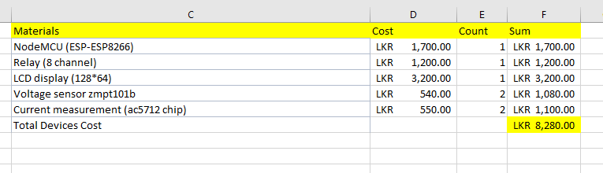

# Gantt chart

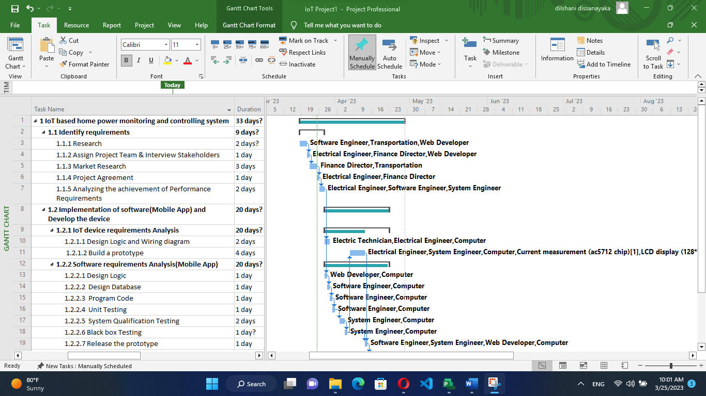

***Official use only***;

**Status:** **Approved / Rejected**

**Date of the status:** ………………………………

**Approved by:**

……………………… …………………………….. ……………………………. ……………………….

Approval Status: **Approved / Rejected**

Date of the Status: …………………………..